Microprocessor 8086

8086 contains two independent functional units:
- Bus Interface Unit (BIU)
- Execution Unit (EU).

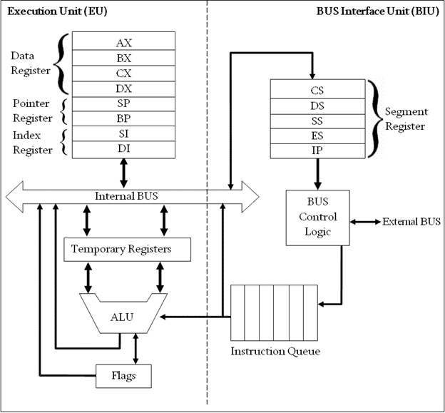
Block Diagram of Intel 8086 Microprocessor (8086 Architecture)

Bus Interface Unit (BIU)
The segment registers, instruction pointer and 6-byte instruction queue are associated with the bus interface unit (BIU).
The BIU:
- Handles transfer of data and addresses,
- Fetches instruction codes, stores fetched instruction codes in first-in-first-out register set called a queue,
- Reads data from memory and I/O devices,
- Writes data to memory and I/O devices,
- The EU tells the BIU from where to fetch instructions or where to read data.
It has the following functional parts:
- Instruction Queue: When EU executes instructions (FIFO), The BIU gets 6-bytes of the next instruction and stores them in the instruction queue and this process is known as instruction pre fetch.
- This process increases the speed of the processor.

- Segment Registers: A segment register contains the addresses of instructions and data in memory which are used by the processor to access memory locations.
- It points to the starting address of a memory segment currently being used.
There are 4 segment registers (16 bit) in 8086 as given below:
  - Code Segment Register (CS): Code segment of the memory holds instruction codes of a program.
  - Data Segment Register (DS): Points to the current data segment;
  - The data, variables and constants given in the program are held in the data segment of the memory.
  - Stack Segment Register (SS): Stack segment holds addresses and data of subroutines.
  - It also holds the contents of registers and memory locations given in PUSH instruction.
  - Extra Segment Register (ES): Extra segment holds the destination addresses of some data of certain string instructions.

- Instruction Pointer (IP): Acts as a program counter.
- indicates to the address of the next instruction to be executed.

Execution Unit (EU)
- The EU receives opcode of an instruction from the queue, decodes it and then executes it.
- While Execution, unit decodes or executes an instruction, then the BIU fetches instruction codes from the memory and stores them in the queue.
- The BIU and EU operate in parallel independently. This makes processing faster.
General Purpose Registers: There are four 16-bit general purpose registers:
AX (Accumulator Register),
BX (Base Register),
CX (Counter Register)
DX(Data Register)

Each of these 16-bit registers are further subdivided into 8-bit registers as shown below:
16-bit registers | 8-bit high-order registers | 8-bit low-order registers
AX | AH | AL
BX | BH | BL
CX | CH | CL
DX | DH | DL

Accumulator Register (AX)
- Consists of two 8-bit registers AL and AH, which can be combined together and used as a 16-bit register AX.
- Stores the 16-bit results of arithmetic and logic operations
- AL contains the high-order byte
- AH contains the high-order byte.
Base Register (BX)
- Consists of two 8-bit registers BL and BH, which can be combined together and used as a 16-bit register BX.
- Used to hold base value in base addressing mode to access memory data
Counter Register (CX)
- Consists of two 8-bit registers CL and CH, which can be combined together and used as a 16-bit register CX.
- Used to hold the count value in SHIFT, ROTATE and LOOP instructions

Data Register (DX)
- Consists of two 8-bit registers DL and DH, which can be combined together and used as a 16-bit register DX.
- Used to hold data for multiplication and division operations

Index Register: The following four registers are in the group of pointer and index registers:
- Stack Pointer (SP)
- Base Pointer (BP)
- Source Index (SI)
- Destination Index (DI)
Stack Pointer (SP)
- SP and BP are used to access data in the stack segment.
- SP contents are automatically updated (incremented/decremented) due to execution of a POP or PUSH instruction.
- Used to hold the offset address of top stack memory
Base Pointer (BP)
- BP contains an offset address in the current SS, which is used by instructions utilizing the based addressing mode.
- Used to hold the base value in base addressing using SS register to access data from memory
Source Index (SI)
- SI is the Source Index Register.
- Which is used to point to memory locations in the data segment addressed by DS.
- By increment the contents of SI one can easily access consecutive memory locations
- Used to hold index value of source operand (data) for string instruction.

Destination Index (DI)
- DI is the Destination Index register performs the same function as SI.
- Used to hold the index value of destination operand (data) for string operations

ALU: It handles all arithmetic and logical operations. Such as addition, subtraction, multiplication, division, AND, OR, NOT operations.
- Flag Register: It is a 16?bit register which exactly behaves like a flip-flop, means it changes states according to the result stored in the accumulator. It has 9 flags and they are divided into 2 groups i.e. conditional and control flags.

- Conditional Flags: This flag represents the result of the last arithmetic or logical instruction executed. Conditional flags are:
  - Carry Flag
  - Auxiliary Flag
  - Parity Flag
  - Zero Flag
  - Sign Flag
  - Overflow Flag

- Control Flags: It controls the operations of the execution unit. Control flags are:
  - Trap Flag
  - Interrupt Flag
  - Direction Flag

8085 Microprocessor | 8086 Microprocessor
It is an 8-bit microprocessor. | It is a 16-bit microprocessor.
It has a 16-bit address line. | It has a 20-bit address line.
It has a 8-bit data bus. | It has a 16-bit data bus.
The memory capacity is 64 KB. | The memory capacity is 1 MB.
The Clock speed of this microprocessor is 3 MHz. | The Clock speed of this microprocessor varies between 5, 8 and 10 MHz for different versions.
It has five flags. | It has nine flags.
8085 microprocessor does not support memory segmentation. | 8086 microprocessor supports memory segmentation.
It does not support pipelining. | It supports pipelining.
It is accumulator based processor. | It is general purpose register based processor.
It has no minimum or maximum mode. | It has minimum and maximum modes.
In 8085, only one processor is used. | In 8086, more than one processor is used. An additional external processor can also be employed.
It contains less number of transistors compare to 8086 microprocessor. It contains about 6500 transistor. | It contains more number of transistors compare to 8085 microprocessor. It contains about 29000 in size.
The cost of 8085 is low. | The cost of 8086 is high.

